BEST FIRST SEARCH ALGORITHM

AIM: To implement a prolog program for Best First Search Algorithm.

OBJECTIVES:
- To implement the Best First Search algorithm in Prolog by selecting the node with the lowest heuristic value.

ALGORITHM:
- Represent each node and its heuristic value.
- Start from the initial node.
- Store the available nodes in an open list.
- Select the node having the smallest heuristic value.
- Expand that node.
- Add its child nodes to the open list.
- Repeat until the goal node is found.

SYSTEM-ARCHITECTURE:
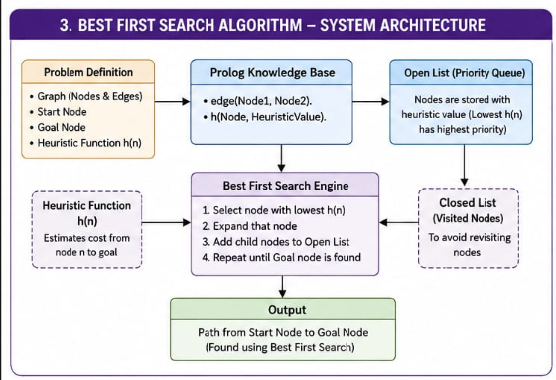

PROGRAM:
% Best First Search

edge(a, b).
edge(a, c).
edge(b, d).
edge(b, e).
edge(c, f).
edge(c, g).
edge(d, h).
edge(e, h).
edge(f, h).
edge(g, h).

% Heuristic values
h(a, 6).
h(b, 4).
h(c, 5).
h(d, 2).
h(e, 3).
h(f, 4).
h(g, 1).
h(h, 0).

% Best First Search
best_first(Start, Goal, Path) :-
best_first_search([node(Start, [Start])], Goal, Path).

best_first_search([node(Goal, Path)|_], Goal, Path).

best_first_search([node(Current, Path)|Open], Goal, Solution) :-
findall(
node(Next, [Next|Path]),
(edge(Current, Next),
\+ member(Next, Path)),
Children
),
append(Open, Children, NewOpen),
sort_nodes(NewOpen, SortedOpen),
best_first_search(SortedOpen, Goal, Solution).

sort_nodes(Nodes, Sorted) :-
predsort(compare_nodes, Nodes, Sorted).

compare_nodes(Order, node(A, _), node(B, _)) :-
h(A, HA),
h(B, HB),
compare(Order, HA, HB).

OUTPUT:
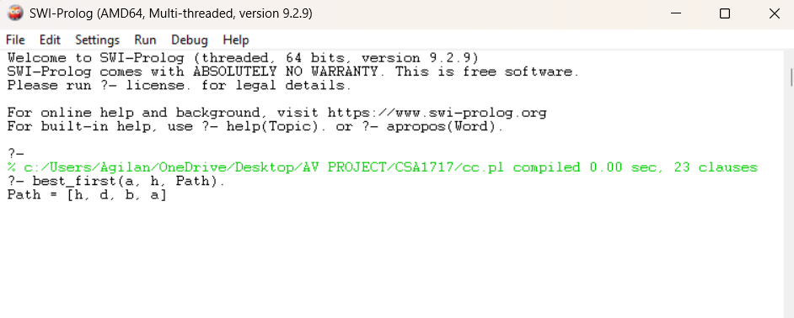

RESULT: Thus the Best First Search Algorithm is implemented successfully using Prolog program.

